**Insight68 Clinical Study Site User Guide Version 1.6**

**Copyright Notice**

© Copyright 2020 Insight68, Inc. All rights reserved.

This document and any accompanying Insight68 products are copyrighted by Insight68, Inc. Any reproduction and/or distribution without prior written consent from Insight68, Inc. is strictly prohibited.

Table of Contents

*Chapter 1:* Read Me First 2

1.1. Audience 3

1.2. Conventions 3

1.3. Technical Support 3

*Chapter 2:* Introduction 4

2.1. Insight68 Overview 5

2.2. Getting Started 5

*Chapter 3:* Home Page 7

3.1. Header 8

3.1.1. Switch To 8

3.1.1.1. Notifications 8

3.1.1.2. Account 9

3.2. Navigation Pane 14

*Chapter 4:* Orders 16

4.1. Order List 17

4.1.1. Available Days 17

4.1.2. Order Table View 18

4.1.3. Order Calendar View 19

4.2. Create New Order 19

*Chapter 5:* Subject 23

5.1. Subject List 24

5.2. Add New Subject 27

5.3. Edit Subject 28

# Read Me First

In this Chapter:

Audience………………...3

Conventions…………….3

Technical Support….......3

## Audience

This guide is intended for Insight68 Clinical Study Site users who have the knowledge of the study being performed on the Subjects. This document provides information about the features available in the Insight68 application for Clinical Study Site User.

## Conventions

The following conventions are followed in this document:

* The text, labels and icon names that are in the User Interface appears in bold text.

For example: To save the changes, click **Save**.

* The URLs and links appear in blue text with an underline.

For example: <https://demo.ai3o.com/account/login>

* The cross-reference appears in italic blue.

For example: Refer to .

* The information that user should pay special attention is mentioned as a ‘**NOTE**’.

For example:

**NOTE:** Only the Sponsor can create the Study.

## Technical Support

Please contact our Technical Support at 98******* or write to us at xyz@insight68.com, to resolve any issues related to the application. When you call, we expect you to be at the computer and to explain the reproduction steps to our executive. Also, specify the actions you performed to resolve the issue.

# Introduction

In this chapter:

……5

Getting Started………..5

## Insight68 Overview

Insight68 is an end-to-end clinical trials management system that brings control, effectiveness and quality information to each study. This web-based clinical trials management system works on the go, allowing you to see and manage real-time operational performance at any place and at whatever point. The system keeps up and manages planning, performing and reporting functions, alongside the details of the participant, following cutoff times and achievements.

## Getting Started

The Admin creates the user profile with username and temporary password. You will have to login to the account with these credentials and set a new password.

To login to the account, perform the following steps:

1. In the web browser, provide the URL:

<https://demo.ai3o.com/account/login>

Figure : Login Page

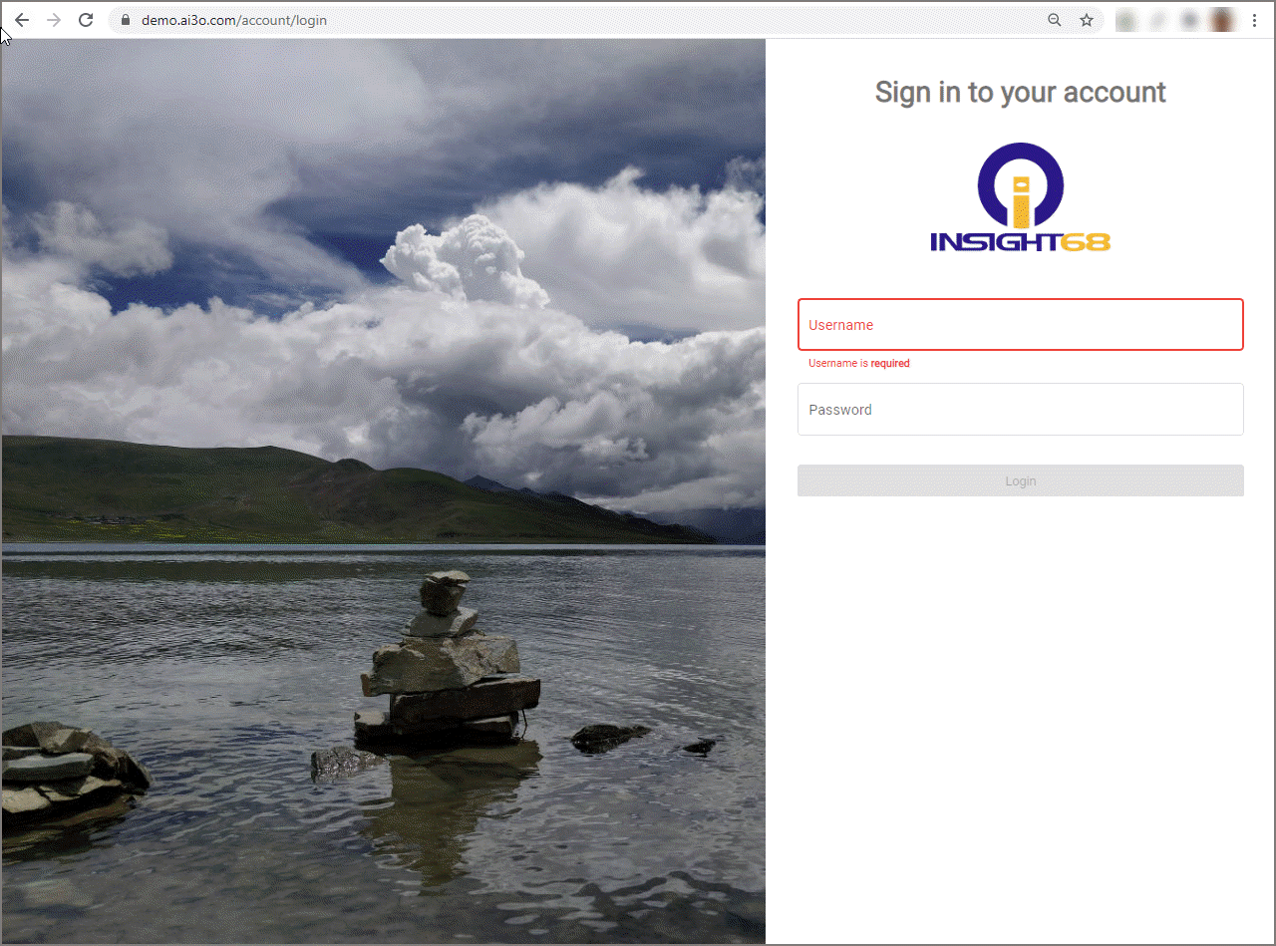

1. In the Login page, provide the following details:

* Username: In the Username box, type the user name.
* Password: In the Password box, type the password.

1. Click Login, the Change Password page displays.

<Change Password page image>

1. Set a new password for your account and click Login.

**NOTE:** Password must contain at least one uppercase, one lower case, one symbol and one numeric character. Password must be between 8-50 characters long.

The Home page displays.

Figure : Home Page

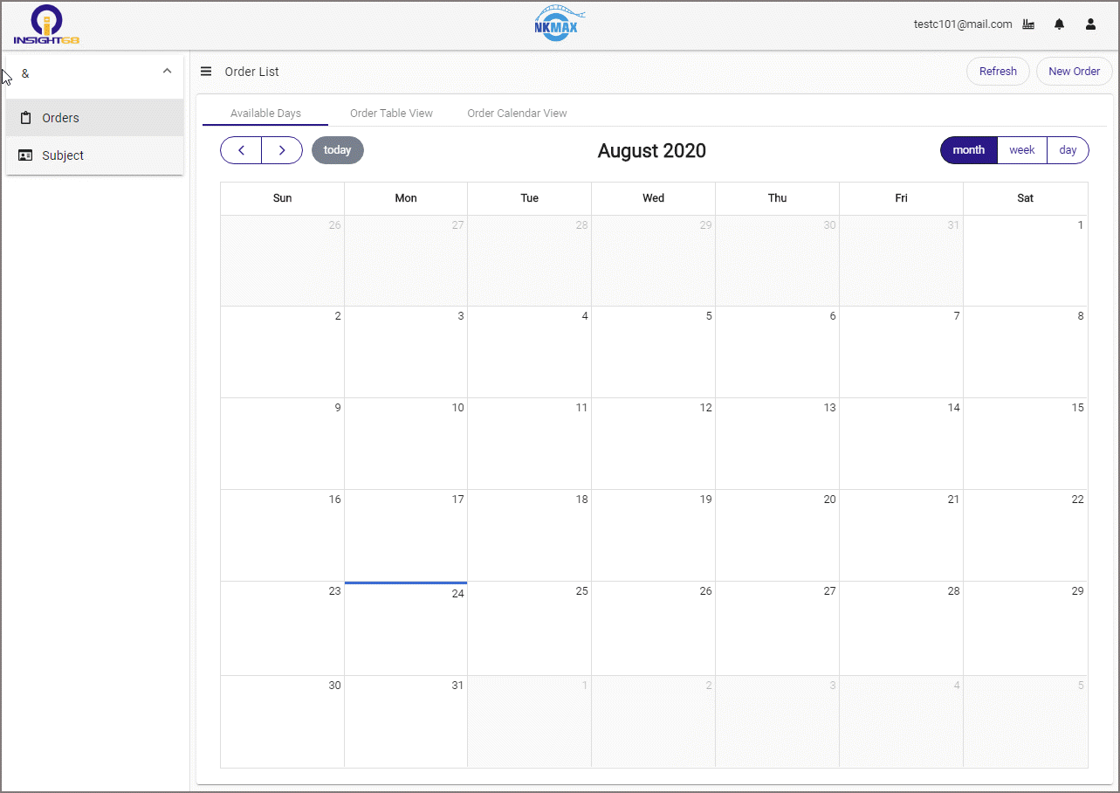

# Home Page

In this Chapter:

Header..............................8

Switch To..........................8

Notifications.....................8

Account............................9

Navigation Pane..............14

The Home page contains a Header on the top and a Navigation Pane on the left side of the page.

## Header

The header has the following options:

* C:\Users\spsoft\Desktop\24-08-2020\New folder\icon3.PNG - Switch To. Refer to .
* C:\Users\spsoft\Desktop\24-08-2020\New folder\icon1.PNG - Notifications. Refer to Notifications.
* C:\Users\spsoft\Desktop\24-08-2020\New folder\icon2.PNG - Account, Refer to Account.

### Switch To

To change the role:

1. Click the Switch To icon C:\Users\spsoft\Desktop\24-08-2020\New folder\icon1.PNG, to display the roles assigned to the user.
2. Select the desired role, the Default Landing Page of the selected role displays.

Figure : Switch To

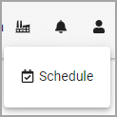

#### Notifications

This option enables the user to view all the notification related to the orders placed by the User.

1. Click the Notifications icon C:\Users\spsoft\Desktop\24-08-2020\New folder\icon1.PNG to view the received notifications when the part is received.
2. To see the details of the Notifications, click View All. The Notifications Center page displays.
3. To select all the notifications in a tab, select the checkbox in the table header.
4. To select individual notification, select the individual checkbox in the first column of the table.
5. To clear all the notifications, click Clear on the top-left corner.
6. To delete all the notifications, click **Delete** on the top-left corner.

The Notifications Center page contains the following tabs:

* Missing: The Missing tab displays all the missed parts that are not received by the user.
* Today: The Today tab displays the notifications received on the current day.
* All: The All tab displays all the notifications.

Figure : Notifications Center

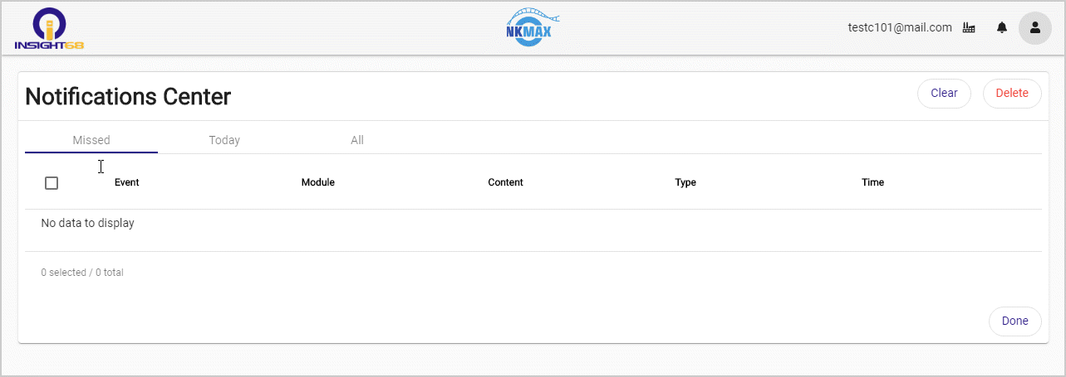

Each tab in the Notifications Center displays the following information:

* Event: The name of the event that describes the status of the sample.
* Module: The Module in which the sample is being processed.
* For example: Inventory, Logistics.
* Content: Additional information regarding the notification.
* Type: The type of notification such as Information or Alert.
* Time: The time and date on which the notification is received.

**NOTE:** Hover over the mouse on the cell of the table to display corresponding details on the tooltip.

#### Account

The option enables you to manage your account, view notifications (related to Inventory, QC, QA and Orders) and sign out of the application.

Figure : Account

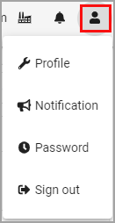

The Accounts section has the following options:

Profile:

This option allows the user to view and/or edit the profile of the clinic. Here, you can also select the landing page that has to display once you login to the application.

To edit the profile of the clinic:

1. Click Profile, the Profile for Clinical page displays.
2. Edit the following details, if necessary:

* First name: The first name of the physician (not mandatory).
* Middle Initial: The middle name of the physician (not mandatory).
* Last name: The last name of the physician (not mandatory).
* Title: The name of the clinic.
* Mobile Number: The number of the clinic (not mandatory).
* Clinical Site: This field is non-editable. This field displays the identification number assigned to the Clinic by the sponsor.
* Email: The registered email address of the Clinic (mandatory).
* Landing Page: Select the desired landing page from the drop-down list (not mandatory).

NOTE: The Order List page is set as the default landing page.

* Role: This field is non-editable. Only Admin has privileges to change the assign or change a Role.

1. To save the changes, click **Save**.
2. To discard the changes, click Delete.

Figure : Profile

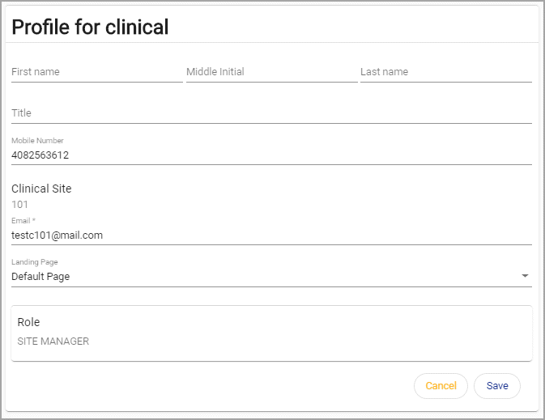

Notification:

This option displays the following Notifications related to each category in a separate table.

For example:

* Inventory Notifications: Displays the notifications related to inventory management.

Figure : Inventory Notifications

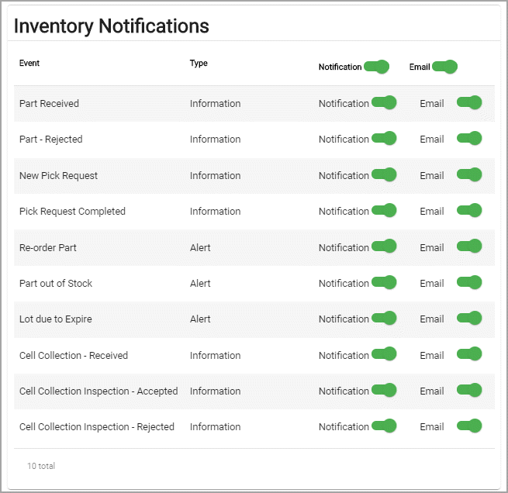

* QC Notifications: Displays the notifications related to part in Quality Control department.

Figure : QC Notifications

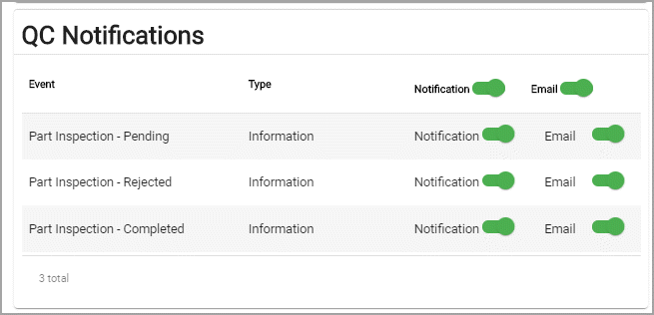

* QA Notifications: Displays the notifications related to status of the part in Quality Assurance department.

Figure : QA Notifications

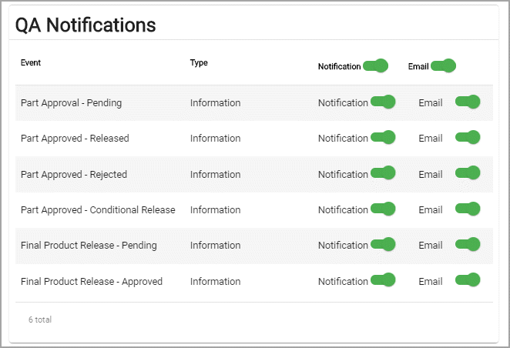

* Orders Notifications:Displays the notifications related to orders on the placed by the User.

**NOTE:** Admin has the privileges to define the type of Notifications you receive.

In the Notification page, each table contains the following columns:

* Event: This column displays the status of the part.

For example: Part Received

* Type: This column displays the type of the notification:
* Information: Indicates that notification is just to share the information about the status of part.
* Alert: Indicates that an alert is generated.
* Notification: To stop receiving the notifications, turn on the switch in this column.
* Email: To stop receiving email notifications, turn off the switch in this column.

Password:

To reset the password:

1. Click Password, the Password for Clinical page displays.
2. Provide the following details:

* Current password: Type the current password of the account.
* New password: Type the new password for the account.
* New password confirmation: Retype the new password to confirm.

1. To save the changes, click **Save**.
2. To discard the changes, click **Cancel**.

Figure : Password

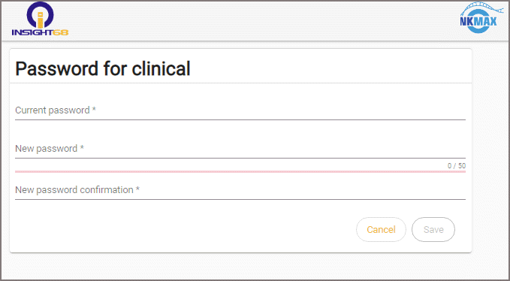

Sign Out:

* To sign out from the application, click Sign out.

## Navigation Pane

The navigation pane on the left side displays the list of Studies that the Clinic is working on. The Study is created by the Sponsor. The Study is the experiment done by the Sponsor to test the drug on a group of Subjects.

* Click the toggle icon , to hide the navigation pane.

NOTE: The Clinical Site User cannot create the Study.

Each Study contains Orders and Subject. To expand the Study, click the Up Arrow icon next to the Study name in the navigation pane:

* Orders: Enables the user to manage record of the orders for each Subject. Refer to .
* Subject: Enables the user to add and edit the details of a Subject. Refer to .

NOTE: The person or the patient on whom the drug is being tested is called the Subject.

# Orders

In this Chapter:

Order List…………….17

Create New Order……19

## Order List

The orders list page has three tabs:

* Available Days: Displays the available days on which the drug shipment can be scheduled. Refer to .
* Order Table View: Displays the list of existing orders. Refer to .
* Order Calendar View: Displays the list of existing orders on a calendar. Refer to .

### Available Days

The Available Days tab displays the monthly, weekly and Day view of the available days on which you can order the drug from the manufacturer (or Sponsor).

On the calendar, ‘Available’ on the corresponding day indicates that you can place a new order for the drug. To create new order from Available Days page:

* Click Available, the New Order page displays. Refer to to place the order for a specific subject.

Figure : Available Days - Available

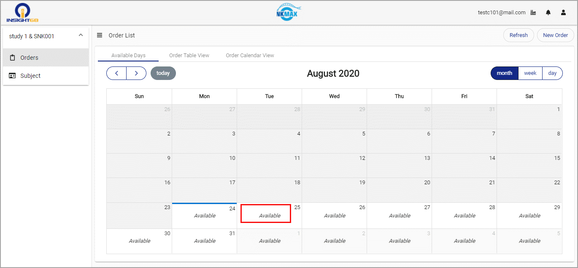

To change the view of the Calendar:

* Month: Click Month to view all the days in a specific Month.
* Week: Click Week to view all the days in a specific Week.
* Day: Click Day to view hourly schedule in a specific day.

Figure : Available Days

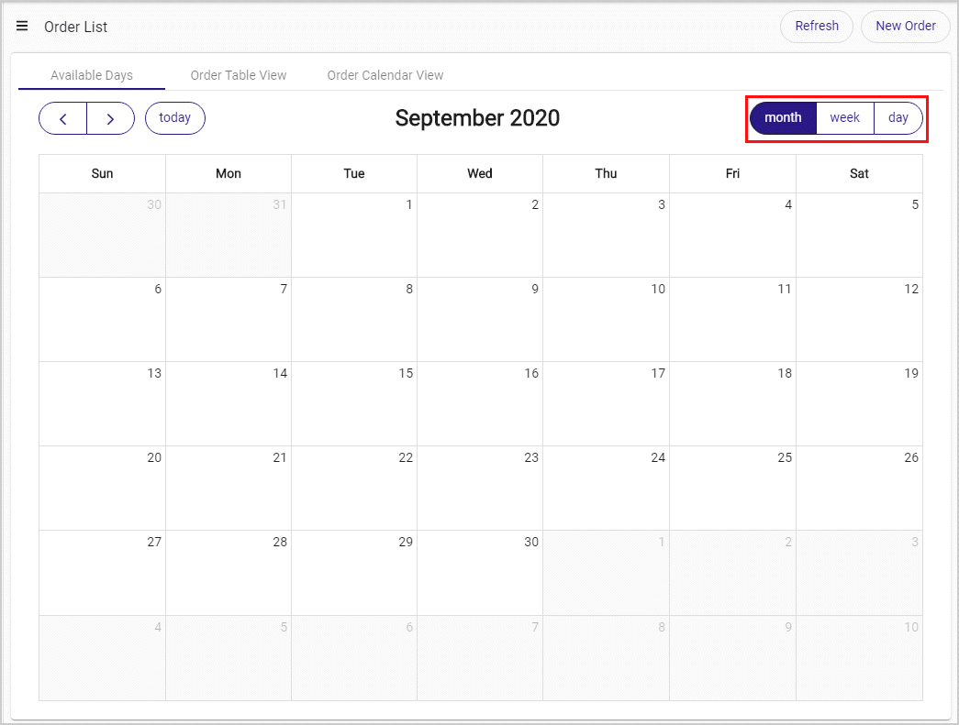

### Order Table View

The Order Table View tab displays the list of orders placed by you in tabular format. To view the details of a desired order, select the radio button on the left side of the table.

To edit a specific order:

1. In the Actions column, click the Edit icon C:\Users\spsoft\Desktop\edit.gif, the Edit Order page displays.

Figure : Edit Order

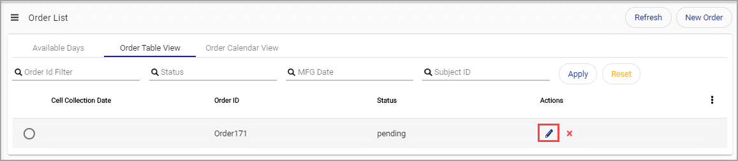

1. Modify the desired fields and click Save to save the changes.

### Order Calendar View

On the calendar, a blue color line appears on the bottom of the cell for the day on which the Order has already been placed.

To change the view of the Calendar:

* Month: Click Month to view all the days in a specific Month.
* Week: Click Week to view all the days in a specific Week.
* Day: Click Day to view hourly schedule in a specific day.

Figure : Order Calendar View

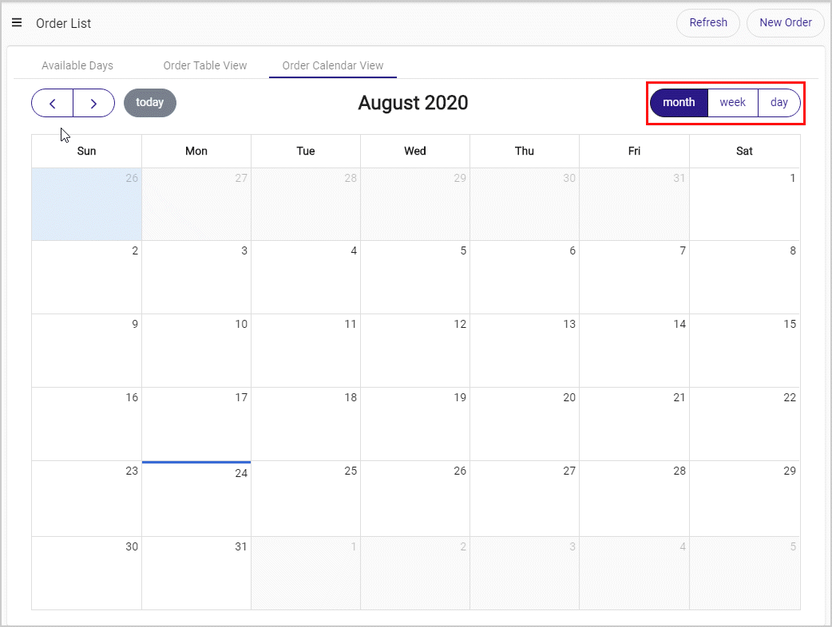

## Create New Order

To create a new order:

1. Click New Order on the top-right corner, the New Order page displays.

Figure : Create New Order

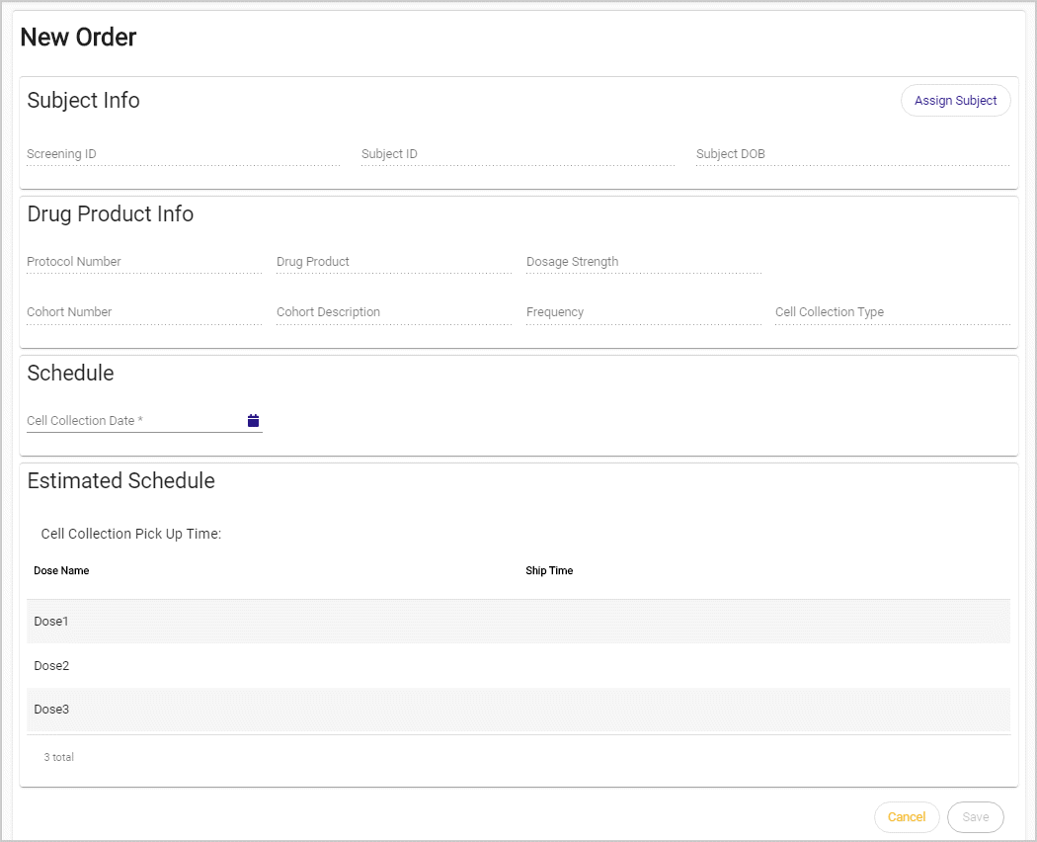

1. To assign a subject to the order, click Assign Subject. The Select Subject dialog displays.

The Select Subject dialog displays the following details of the all the available subjects:

* Screening ID: The Screening Identification of the Subject that is auto-generated once the Subject is registered for screening. The Screening ID is unique for each Subject.
* Subject ID: The Subject Identification of the Subject that is auto-generated when the status of the Subject is changed to ‘Enrolled’. The Subject ID is unique for each Subject.

NOTE: Only the Subjects that are qualified in the screening process are given the Subject ID.

* Subject DOB: The date on which the subject was born.
* Gender: The gender (Male/Female) of the Subject.

1. To filter the desired Subject, type the Screening ID in the Screening ID Filter box and click Apply.
2. To clear the Screening ID Filter box, click Reset.
3. Select the Screening ID of the desired Subject and click Confirm. The selected Subject details are displayed in the New Order page.

NOTE: To close the Select Subject dialog without selecting the Subject, click Cancel.

Figure : Select Subject

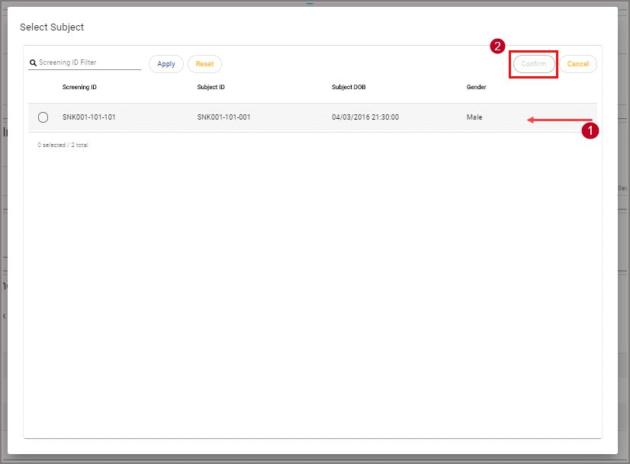

1. In the New Orders page, the following details of the selected Subject are displayed:

* Subject Info: Displays Screening ID, Subject ID and Date of Birth of the Subject.
* Drug Product Info: Displays the following details:
* Protocol Number: Protocol Number is Unique for each drug which is defined by the Sponsor.
* Drug Product: The drug being tested on the Subject.
* Dosage Strength: The amount of drug prescribed to subject.
* Cohort Number: This is defined by the Sponsor. The cohort is a generally described as a group of people with similar health condition who are considered for testing the drug.
* Frequency: The number of times the drug has to be injected to the Subject in a particular duration.
* Cell Collection Type: This defines the type of cells that are collected from the blood. For example: Whole Blood

1. In the Schedule section, click the Calendar icon and select the date on which the collected samples from the Subject must be picked up and sent to the Sponsor.
2. In Estimated Schedule section, the following details are auto-generated:

* Dose Name: The name of the drug prescribed to the Subject.
* Ship Time: The time and date on which the dosage has been shipped to the clinic.

1. To create the order, click Save.

Figure : Schedule

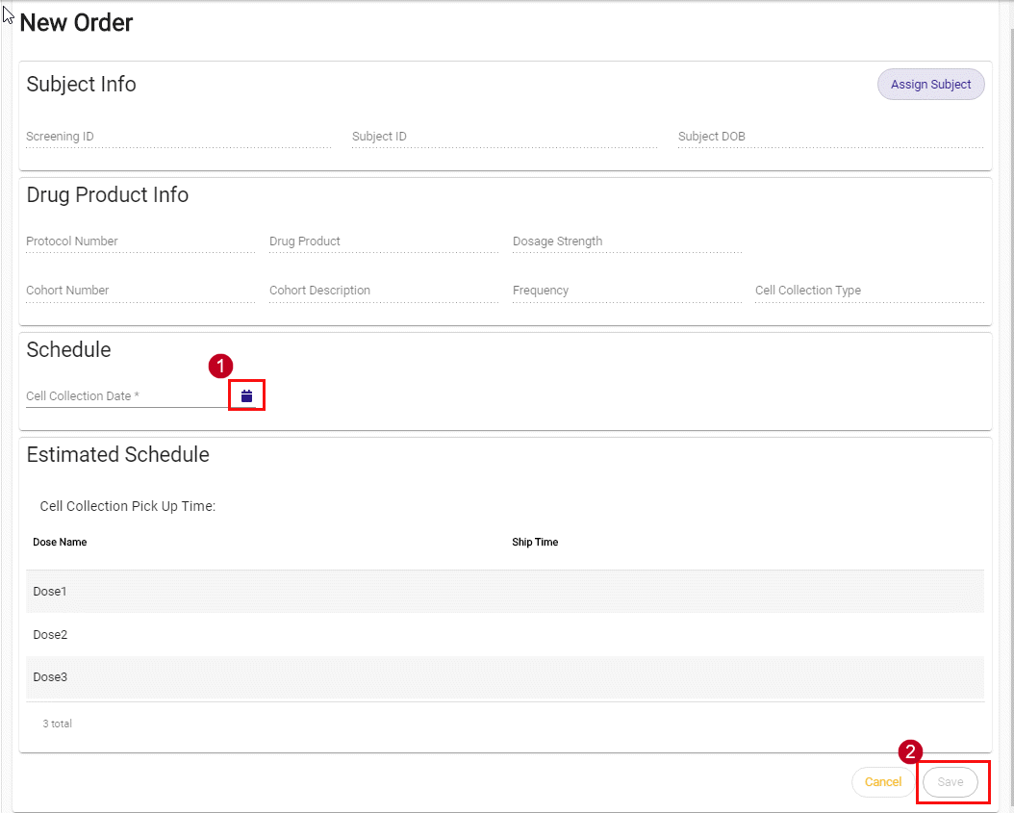

# Subject

In this chapter:

Subject List……………24

Add New Subject……...27

Edit Subject…………...28

This tab enables the user to register a new Subject, edit the status of the existing Subject, and place an order for a specific Subject.

The following options are available in this page:

* Refresh: To reload the page, click Refresh.
* New Subject: To add a new Subject to the Study, click New Subject. Refer to .
* Filter:
* To filter a specific Subject, type the Subject ID and/or Screening ID, click Apply.
* To clear the text in the Subject ID box and Screening ID box, Click Reset.

Figure : Subject List

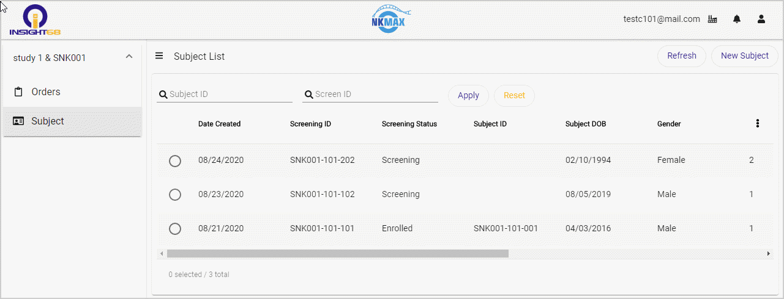

## Subject List

This page displays the details of the all the Subjects in tabular format:

* Radio button: Select the radio button of the desired Subject to display the Subject details
* Date Created: Displays the date on which the Subject registered for Screening.
* Screening ID: Displays the unique Identification Number assigned to the Subject when the Subject registers for Screening.
* Screening Status: Displays the status of the Subject such as Screening, Screening Failed, Enrolled or Permanently Discontinued.
* Screening: Indicates that the Screening process is still in progress. Under the Screening process the Subject undergoes required evaluations to decide whether the Subject’s health condition is suitable for testing the drug or not.
* Screening Failed: Indicates that the Subject failed the Screening process and that the Subject is not suitable for testing the drug.
* Enrolled: Indicates that the Subject’s health condition is suitable for drug testing. Once the status is changed to ‘Enrolled’, the Subject ID is auto-generated.

NOTE: The Subject ID is generated only when the status of the Subject is ‘Enrolled’. You can create an order only for the Subjects with Screening Status as Enrolled.

* Permanently Discontinued: Indicates that the Subject is not suitable for the Study and will not be considered for any further Studies.
* Subject ID: The unique Identification Number assigned to the Subject when the Subject has successfully passed the Screening process. The Subject ID is assigned to Subjects those who pass the Screening process.
* Subject DOB: Displays the date of birth of the Subject.
* Gender: Displays the gender of the Subject as either Male or Female.
* Cohort Number: Displays the Cohort Number assigned to the Subject.
* Drug Product Name: Displays the name of drug that is being tested on the Subject.
* Dosage Strength: Displays the concentration of drug injected to the Subject.
* Frequency: Displays the number of times the Subject must take the drug in a specific period of time.

Example:

1Every 3 Weeks: Indicates that the drug must be given to the Subject once in every three weeks.

* Actions:
* Edit: To edit the status and details of the Subject, click the Edit icon. Refer to .
* Change Status: To change the Status of the Subject, Click the Change Status icon. The Screening Status dialog displays. Select the desired Status and click Confirm.

Figure : Change Screening Status

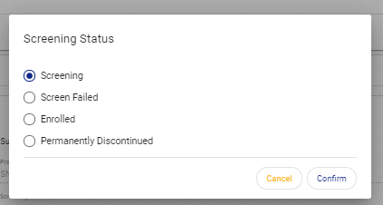

* New Order: To place a new order for the Subject, click the New Order icon. Refer to .

NOTE: Click the Select Columns icon, to select the columns to be displayed in the Subject List table.

Figure : Select Columns

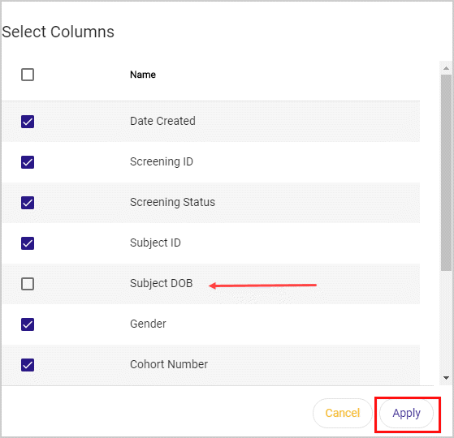

## Add New Subject

To register a new Subject:

1. Click New Subject, the New Subject page displays.
2. Define the following details:

* Subject DOB: Date of birth of the Subject.
* Subject Initials: Type the initials of the name of the Subject.
* Subject Gender: Select the gender of the Subject as Male or Female.
* Cohort Number: Select the desired cohort number from the drop-down list. The number of values in the Cohort Number drop-down is defined by the Sponsor. Once the Cohort Number is selected the Cohort Description, Protocol Number, Drug Product and Dosage Strength are auto-populated.

NOTE: Cohort Description, Protocol Number, Drug Product and Dosage Strength are read-only fields across the whole application and are defined by the Sponsor.

Figure : New Subject

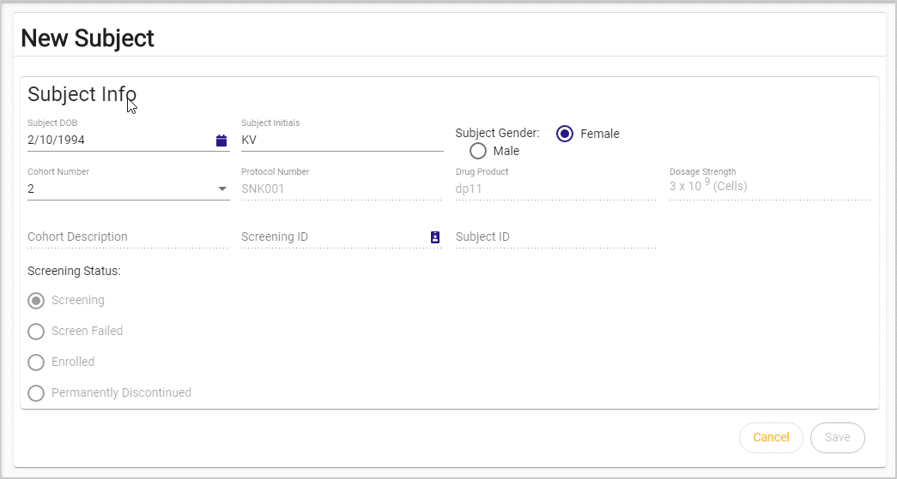

* Screening ID: To generate the Screening ID, click the Screening ID icon.
* Screening Status: By default, Screening Status is selected as Screening. You cannot change the Screening Status while adding the new Subject to the Study.

NOTE: Once the Cohort Number is selected and Screening ID is generated, the Cohort Number cannot be changed.

1. To add the Subject to the Study, click Save.

Figure : Generate Screening ID

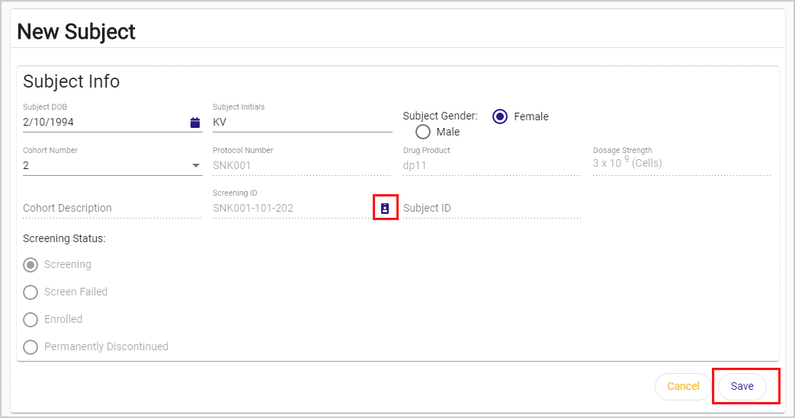

1. The saved Subject appears in the Subject List table.

Figure : Saved Subject

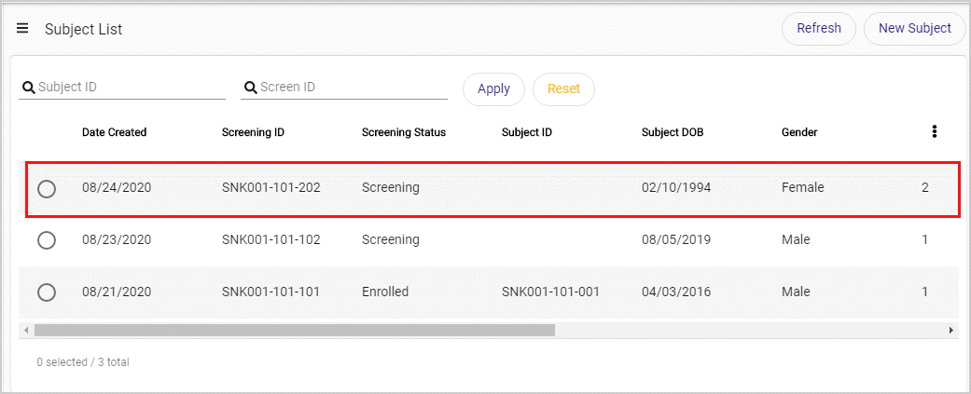

## Edit Subject

To edit the details of the Subject:

1. On the Subject List page, in the Actions column, click the Edit icon C:\Users\spsoft\Desktop\edit.gif. The Edit Subject dialog displays.
2. Edit the following details, if necessary:

* Subject DOB
* Subject Initials
* Subject Gender
* Screening Status

1. To save the changes, click Save.
2. To discard the changes, click Cancel.

Figure : Edit Subject

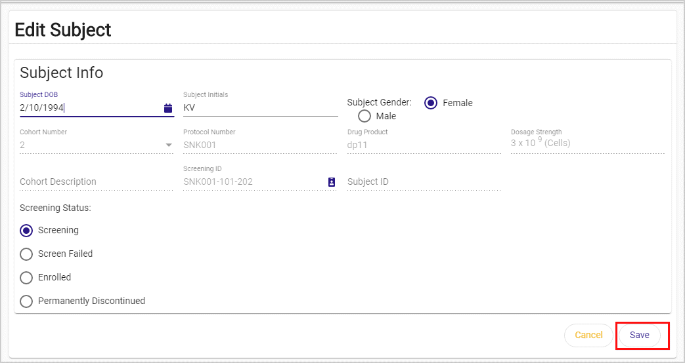

**Notes:**